Famous Faces - Match these faces to the names

Answers

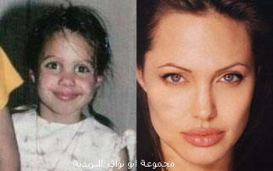  1 Angelina-Jolie | 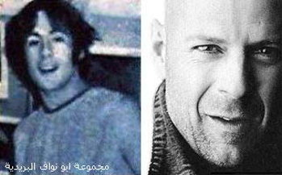  2 Bruce-Willis
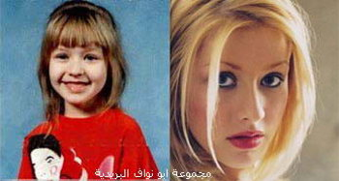3 Christina-Aguilera | 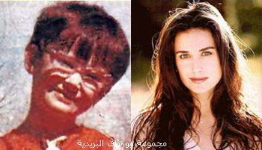  4 Demi-Moore
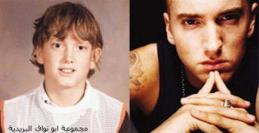5 Eminem | 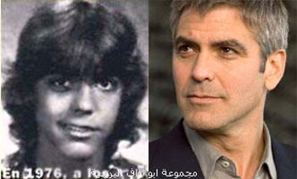6 George-Clooney
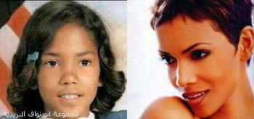  7 Halle-Berry | 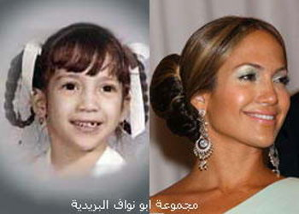  8 Jennifer-Lopez
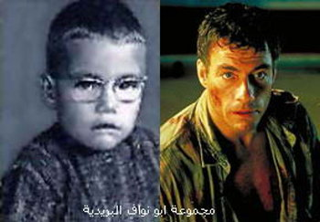  9 Jean-Claude-Van-Damme | 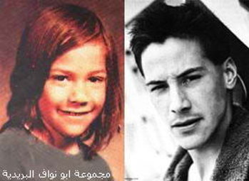10 Keanu-Reeves
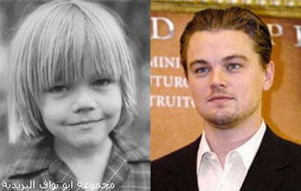  11 Leonardo-Di-Caprio | 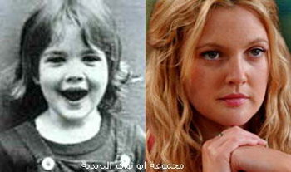  12 Drew-Barrymore

Christina-Aguilera George-Clooney
Eminem Halle-Berry
Bruce-Willis Jean-Claude-Van-Damme
Demi-Moore Jennifer-Lopez
Angelina-Jolie Keanu-Reeves
Drew-Barrymore Leonardo-Di-Caprio

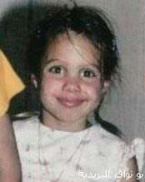 |  | 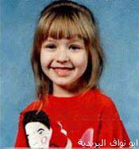
1 | 2 | 3
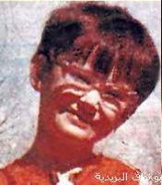 | 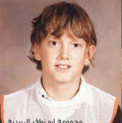 | 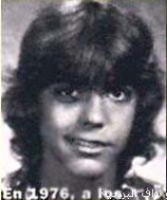
4 | 5 | 6

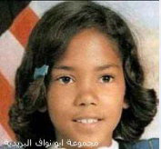 | 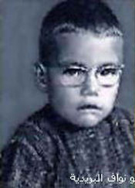 | 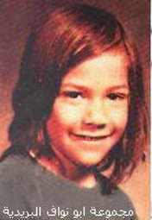
7 | 8 | 9
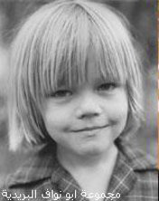 | 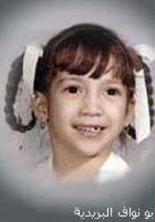 | 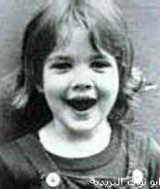
10 | 11 | 12

Christina-Aguilera George-Clooney
Eminem Halle-Berry
Bruce-Willis Jean-Claude-Van-Damme
Demi-Moore Jennifer-Lopez
Angelina-Jolie Keanu-Reeves
Drew-Barrymore Leonardo-Di-Caprio

